14.03 Virtual Lecture Notes
The Caesar Shift
The Caesar Shift cipher is a simple encryption technique based on substitution. In this example, a shift of three was chosen as the key. Each letter in a plaintext message is replaced by the letter three positions further down the alphabet. For example, with a Caesar Shift of three, the letter D is substituted for the letter A. Can you decode the message shown? |  |  |  | 
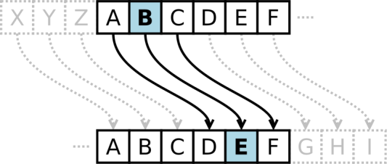 | FRPSXWHU VFLHQFH URFNV
The Caesar Shift does not seem very secure, but keep in mind that most of his adversaries were illiterate. As long as the generals could decode the messages, security was maintained. However, Caesar apparently had more sophisticated encryption techniques when dealing with his political enemies.
A cipher utilizes an algorithm and a key, which specify the exact details of how to encrypt a message. The Caesar Shift algorithm designates which letter in a cipher alphabet to substitute in the plaintext alphabet. For example, if the consecutive letters of the alphabet (x) are represented by the integers 0–25 (e.g., a = 0, b = 1, z = 25), the encryption ( E_{n}) or decryption (D_{n}) of a letter x by a shift n can be calculated as follows:
Consequently, writing a program to perform the Caesar Shift substitution cipher is fairly simple. Determine the identity of each consecutive letter in the plaintext message and substitute the corresponding shifted letter in the cipher alphabet. Decrypting can be done in reverse.

Computer Science Rocks

